3 STEP GUIDE TO ZOOM MEETINGS

- I will send you an invite to our meeting which will be sent from my usual email address.
The invite will come in this format:
If you already have a Zoom account, you can click on the link here.

You have been invited to the following event.
Progress Meeting
If not, click here to join. You will be asked to enter a unique password which will be shown here.
When | Tue 7 April 2020 11:00—11:30 United Kingdom Time
Where | https://zoom.us/j/91054071655?pwd=NzhJcjBweDdJcnc2MXMwOWFQMGNQZz09 (map)
Calendar | clientemail@email.com
Who | · adviseremail@email.com - organiser  · clientemail@email.com
more details >>
Adviser Name is inviting you to a scheduled Zoom meeting.

Join Zoom Meeting
https://zoom.us/j/91054071655?pwd=NzhJcjBweDdJcnc2MXMwOWFQMGNQZz09

Meeting ID: 123 456 789
Password: 123456

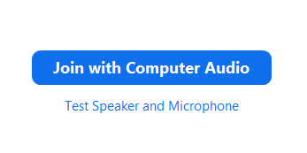
- The following prompt will then appear on the screen. Press “Join with computer audio” to go straight to the meeting.
After which, you will be held in a virtual waiting room until I authorise entry to the meeting. This is a security measure to ensure unauthorised participants cannot gain access.

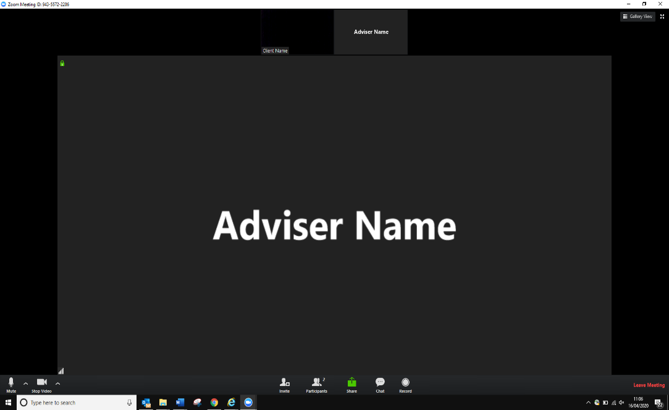
You will appear on the screen if your video is switched on.
I will also be on the screen here.
You will have controls here (see below).

- Check your settings.
If the audio and video icons have a cross through them click on the icon to switch them on.
The ‘more’ button will display more options. However, for our meeting it is unlikely that we will need these.
